Machine Learning Pipeline

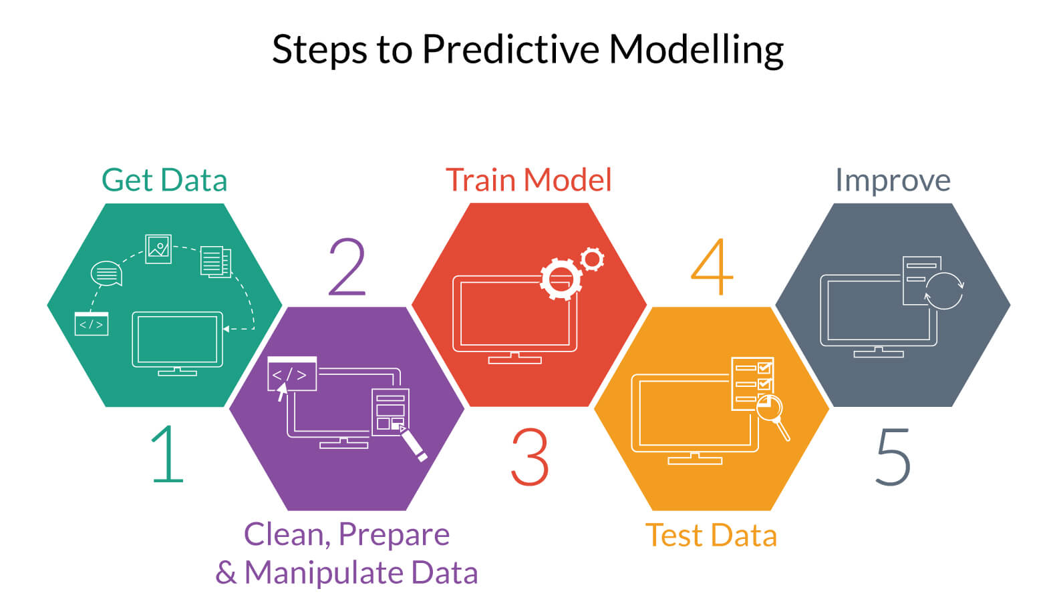

Data Mining
The first step in any machine learning program is collecting data and selecting the dataset most appropriate for your problem. We collated data from the following sources:
Datasets used (2):
1.
1. AICTE dashboard (EDA)
2. IKDD Data (EDA + Salary Predictions)
2. Top 500 Cities (EDA): It was created merging the census 2011 of Indian Cities with Population more than 1 Lac and City wise number of Graduates from the Census 2011. (http://censusindia.gov.in/201 & http://www.censusindia.gov.in/

Data Preprocessing
Data preprocessing is a technique that involves transforming raw data into an understandable format. Real-world data is often incomplete, inconsistent, and/or lacking in certain behaviors or trends, and is likely to contain many errors. Data preprocessing is a proven method of resolving such issues.
First, we adjusted the skewness of the predictor variable, salary, by logarithmic normalisation of the values.
Skewed and normalized salary
Following this, each value in the dataset was represented in a numerical format. Null or zero values were replaced by the mean of the other values.

Feature Selection
Attributes that were relevant for the prediction were identified while the others were dropped. These relevant features were then checked for heteroscedasticity and skewness.

<include one or two scatterplots> college tier and gpa

Model Building and Selection

The dataset was split into training dataset and testing dataset in the ratio of 0.8:0.2

The following machine learning algorithms were used to build predictive models:
SVM, Random Forest, Ridge Regression, Lasso Regression and ANN(MLP)

Each of these models were parameter tuned using exhaustive grid search. <plot for hyperparams>

After building the model for each of the above algorithms, it was applied to the testing dataset and the difference between the predicted value and true value was plotted against the true value. The root mean square error was computed as follows:

<insert table> error along with one plot - ridge

Since the lowest value of the RMSE was observed for Ridge Regression, this model was selected and finally the model was trained.

Model Application
The model was applied to the testing dataset and correspondingly the salaries were predicted.
Finally, we plotted a histogram to visualise the distribution of the predicted salaries to ascertain whether the distribution was similar to that of the training set salaries. As a result, our methodology was validated since the distribution was visibly similar.

<insert plots>

